OPERATING SYSTEMS
ASSIGNMENT 2 – CO2
Process Management, CPU Scheduling, Threads, IPC, Synchronisation and Deadlock Handling
Name:Madhumitha C.V
Register Number: 1921260056
Course faculty:Geetha. P

Certificate and Declaration
CERTIFICATE
This is to certify that the assignment titled “Operating Systems – Assignment 2” is a record of work carried out by the student named on the cover page as part of the course requirements, under the guidance of the course faculty.
DECLARATION
I declare that this report has been prepared for academic learning. Program outputs and performance measurements must be verified by executing the programs on the student’s own Linux system. Any measured values included in the final submission should be replaced with actual observations.

Acknowledgement
I express my sincere thanks to the course faculty for providing the Operating Systems Assignment 2 and guidance on process management, scheduling, threads, inter-process communication, synchronisation and deadlock handling.
I also acknowledge the developers and maintainers of Linux, GCC, POSIX threads and the C standard library. These tools make it possible to observe operating-system behaviour through practical programs.
This report combines conceptual explanations with implementation plans. The student should execute every program, capture terminal screenshots and commit each task progressively to the required GitHub repository.

Abstract
Operating systems coordinate processes, allocate CPU time, support communication and protect shared resources. Poor process design can cause high context-switch overhead, excessive memory use, long response times, race conditions and deadlocks.
This assignment studies six connected areas through realistic contexts: an online examination server, a cloud video-encoding service, a traffic-camera number-plate reader, a weather-station pipeline, railway ticket booking and a shared laboratory equipment scheduler.
The report explains core concepts, gives C implementations for the supplied code-completion tasks, calculates scheduling metrics, compares alternative designs and discusses complexity. The final recommendations favour designs that balance responsiveness, throughput, fairness, safety and implementation cost.

Contents and Assignment Scope
Q1: Processes and process states — online examination server (6 marks).
Q2: CPU scheduling — cloud video-encoding service (8 marks).
Q3: Threads — traffic-camera number-plate reader (6 marks).
Q4: Inter-process communication — weather-station data pipeline (6 marks).
Q5: Synchronisation — critical sections, semaphores and monitors (11 marks).
Q6: Deadlock handling and Banker’s algorithm — shared laboratory equipment scheduler (13 marks).
The source assignment requires individual execution, a GitHub repository, a README, source files, command outputs and screenshots. The report explains the work; it does not replace execution evidence.

Learning Objectives
The objectives are to understand process states and PCBs; evaluate process-versus-thread designs; calculate CPU scheduling metrics; implement Round Robin; use POSIX threads; compare thread models; implement pipe communication; protect shared data with semaphores and mutexes; and apply Banker’s safety and request algorithms.
A further objective is to evaluate alternatives rather than merely define them. Each design is judged using response time, waiting time, turnaround time, CPU utilisation, memory consumption, synchronisation overhead, scalability and failure isolation.

Q1 — Processes: Meaning and Role
A process is a program in execution. It includes program code, data, stack, heap, CPU state and operating-system resources. A server may create a process for each active student session, while additional processes handle auto-saving, authentication and proctoring.
A process provides a protected address space. This isolation is useful when components are untrusted or may fail independently. However, creating thousands of processes increases memory consumption and scheduling overhead. The operating system must maintain process metadata and switch address spaces when execution moves between processes.
For an examination server with 2,000 concurrent sessions, process-per-session is easy to reason about but may be unnecessarily expensive. A worker pool or event-driven design can reduce resource use while keeping requests isolated at an application level.

Q1 — Five Process States
NEW: the process is being created and its PCB is initialised. READY: it is in memory and waiting for CPU time. RUNNING: its instructions are currently being executed by a CPU core. WAITING/BLOCKED: it cannot continue until an event such as disk, network or keyboard I/O completes. TERMINATED: execution has finished or the process has been stopped.
A process moves from ready to running when the scheduler dispatches it. A running process may return to ready after preemption. It enters waiting when it requests unavailable I/O, and returns to ready when the event completes. It enters terminated after exit.
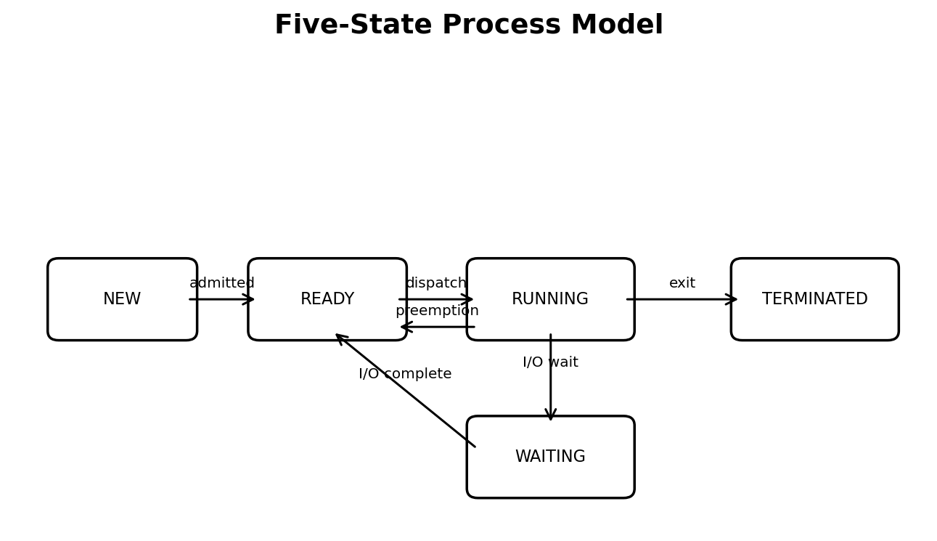

Q1 — Process State Transitions
The state diagram is useful when diagnosing a session that appears to hang. If many sessions are waiting, the bottleneck may be storage, database access or network I/O rather than CPU. If many are ready, CPU capacity or scheduling policy may be insufficient.
The scheduler should distinguish a blocked process from a runnable process. Giving CPU time to a process that is waiting for I/O cannot make that I/O complete. Monitoring state counts over time helps identify the actual bottleneck.
In Linux, commands such as ps -eo pid,ppid,stat,comm and top show process information. The STAT column includes state indicators; exact output depends on the system and timing.

Q1 — Process Control Block
A Process Control Block (PCB) is the kernel data structure that stores information required to manage a process. It allows the operating system to stop one process and later resume it correctly.
Typical PCB fields include process identifier (PID), parent PID, process state, program counter, CPU registers, scheduling priority, memory-management information, open-file descriptors, I/O status, accounting information and security credentials.
During a context switch, the kernel saves the running process’s CPU state and restores the state of the next process. This bookkeeping is essential but contributes to switching overhead.
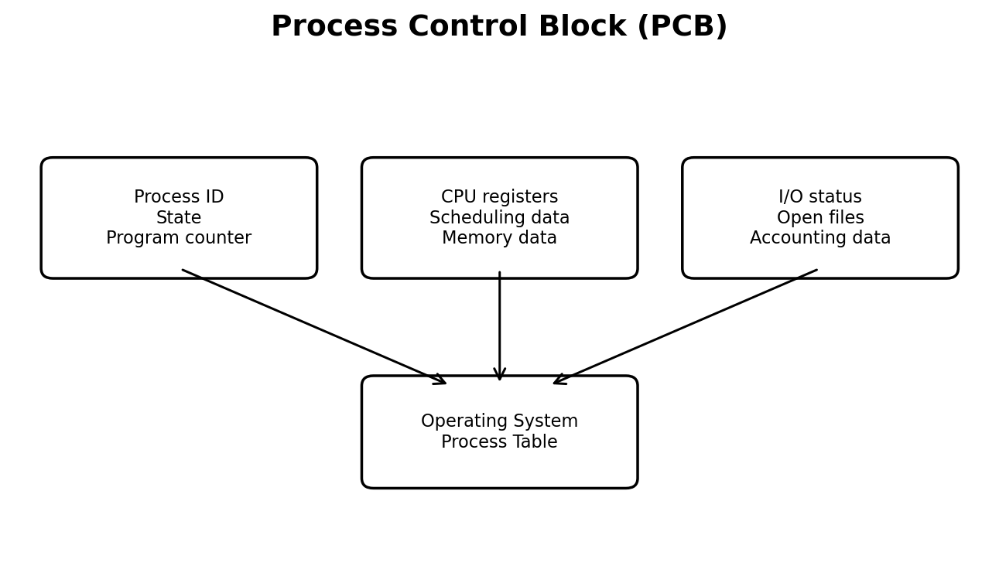

Q1 — fork(), ps and /proc
The fork() system call creates a child process. The child receives a new PID and initially has a logical copy of the parent’s address space, commonly implemented using copy-on-write. fork() returns 0 in the child, the child PID in the parent, and -1 on failure.
The ps command provides a snapshot of process information. The /proc filesystem exposes kernel-maintained information through files such as /proc/<pid>/status, /proc/<pid>/stat and /proc/<pid>/cmdline.
A parent should normally call wait() or waitpid() to collect the child’s exit status. If it does not, a terminated child can remain as a zombie until reaped.

Q1 — C Program Using fork()
The following program creates one child, prints both process identifiers and waits for the child. It is a compact demonstration suitable for Linux and GCC.
#include <stdio.h>\n#include <unistd.h>\n#include <sys/wait.h>\n#include <stdlib.h>\n\nint main(void) {\n pid_t pid = fork();\n if (pid < 0) { perror("fork"); return 1; }\n if (pid == 0) {\n printf("Child PID=%d, parent=%d\\n", getpid(), getppid());\n _exit(0);\n }\n printf("Parent PID=%d, child=%d\\n", getpid(), pid);\n waitpid(pid, NULL, 0);\n return 0;\n}

Q1 — Compile, Run and Observe
Compile: gcc -std=c11 -Wall -Wextra fork_demo.c -o fork_demo. Run: ./fork_demo. Observe processes using ps -ef | grep fork_demo while a longer-running child is active. Inspect a process with cat /proc/<PID>/status.
The output order of parent and child messages is not guaranteed because the scheduler decides which runs first. The PID values also change on every execution. A valid report should attach the actual terminal screenshot from the student’s machine.
The program demonstrates creation and parent-child relationship. For a stronger observation, add sleep(10) in the child, run the program in one terminal and inspect it from another terminal.

Q1 — Cost of 2,000 Processes
Context-switch cost includes saving and restoring registers, scheduler bookkeeping, cache disruption and potentially address-space changes. The cost is not a fixed universal number; it depends on CPU architecture, kernel, workload and cache behaviour.
Memory cost includes the process’s virtual address-space mappings, page tables, kernel task structures, stacks and application allocations. Copy-on-write reduces immediate copying after fork(), but it does not make thousands of independent processes free.
I/O waiting is another major factor. Examination sessions may wait for database writes, video upload, network packets or storage. If the server is I/O-bound, adding CPU workers alone will not solve the delay.

Q1 — Process or Thread or Worker Pool
One process per student gives strong address-space isolation but creates high memory and management overhead. One thread per student shares the server’s address space and is cheaper to create, but a memory corruption bug can affect the whole process. A fixed worker pool limits the number of active execution contexts and provides predictable resource usage.
Recommended design: use a bounded worker pool or asynchronous event-driven server, with a queue for incoming work. Separate critical services such as proctoring or media processing when stronger fault isolation is needed. Keep session data logically separated and validate every request.
The decision is a balance: use processes for isolation boundaries, threads for shared-memory parallelism, and pools to control concurrency.

Q1 — Alternative: Thread per Session
A thread has its own stack, register state and thread-local storage, while sharing the process code, heap, global variables and open file descriptors. A thread switch within one process can be cheaper than switching between unrelated processes because the address space is shared, although the exact cost depends on implementation.
A thread stack is usually much smaller than a complete process address space. However, 2,000 threads still consume stack reservations, kernel or runtime metadata and scheduling resources. Thread-per-session is therefore not automatically scalable.
If one thread crashes because of an invalid memory access, the entire process may terminate. This is a major disadvantage compared with separate processes. Use defensive programming, bounded pools and process isolation for risky components.

Q1 — Q1 Evaluation and Conclusion
For a large examination service, a process for every student is usually not the best default. A bounded pool reduces the number of schedulable entities and limits memory consumption. A thread pool can serve network requests efficiently; separate processes can isolate components with different reliability or security needs.
Monitor ready-queue length, blocked processes, CPU utilisation, memory usage, request latency and database response time. These measurements identify whether scaling should target CPU, memory, storage or network resources.
Evidence to submit: process-state diagram, PCB diagram, fork() source, compiler command, ps output, /proc output, and a short comparison of process-per-session, thread-per-session and worker-pool designs.
Practical note: include actual terminal output and screenshots from your own execution.

Q2 — CPU Scheduling: Introduction
CPU scheduling selects a ready process for execution. The video-encoding service contains short thumbnail jobs and long full-film jobs. If a long job starts first under a non-preemptive policy, short jobs may wait for a long time.
Important metrics: completion time is when a process finishes; turnaround time (TAT) = completion time − arrival time; waiting time (WT) = turnaround time − CPU burst; response time = first CPU start − arrival time.
The supplied code uses P1–P4 with arrival times 0, 1, 2, 3 and burst times 8, 4, 9, 5. Round Robin uses a time quantum of 3. This data set is used below for a consistent comparison.

Q2 — FCFS Scheduling
First-Come, First-Served (FCFS) runs processes in order of arrival and is non-preemptive. With the supplied jobs, the order is P1, P2, P3, P4.
Gantt chart: P1 0–8 | P2 8–12 | P3 12–21 | P4 21–26. Completion times are 8, 12, 21 and 26. Turnaround times are 8, 11, 19 and 23. Waiting times are 0, 7, 10 and 18.
Average TAT = 15.25 time units. Average WT = 8.75 time units. Response times equal waiting times for this non-preemptive single-CPU schedule. FCFS is simple and fair by arrival order, but it suffers from the convoy effect when a long job delays many short jobs.

Q2 — SJF Scheduling
Shortest Job First (SJF) selects the ready process with the smallest CPU burst. The non-preemptive version does not interrupt a process after it starts. At time 0 only P1 is available, so P1 runs first. At time 8, P2, P3 and P4 are ready; P2 is shortest, then P4, then P3.
Gantt chart: P1 0–8 | P2 8–12 | P4 12–17 | P3 17–26. Completion times: P1=8, P2=12, P3=26, P4=17. TAT: 8, 11, 24, 14. WT: 0, 7, 15, 9.
Average TAT = 14.25. Average WT = 7.75. SJF reduces average waiting when burst estimates are accurate, but long jobs can starve if short jobs keep arriving.

Q2 — SRTF Scheduling
Shortest Remaining Time First (SRTF) is the preemptive form of SJF. Whenever a new process arrives, the scheduler compares its burst with the remaining time of the running process and may preempt the current process.
For the supplied data, one valid schedule is P1 0–1, P2 1–5, P1 5–12, P4 12–17, P3 17–26. At time 1, P2 has a shorter burst than P1’s remaining 7, so it preempts P1. At time 2 and 3, P2 remains the shortest.
Completion times: P1=12, P2=5, P3=26, P4=17. TAT: 12, 4, 24, 14. WT: 4, 0, 15, 9. Average TAT = 13.50; average WT = 7.00. Response times: P1=0, P2=0, P3=15, P4=9.

Q2 — Priority Scheduling
Priority scheduling chooses the highest-priority ready process. The assignment does not specify numeric priorities, so this report states an explicit illustrative assumption: P1=2, P2=1, P3=4 and P4=3, where a smaller number means higher priority. Non-preemptive priority scheduling is assumed.
At time 0, P1 starts because it is the only ready job. At time 8, P2 has the highest priority, followed by P4 and P3. The resulting order is P1, P2, P4, P3, identical to the non-preemptive SJF order for this chosen priority set.
This is an assumption for demonstration, not a priority set supplied by the assignment. In an actual submission, replace it with faculty-provided priorities if any. Starvation can occur when low-priority work is continually postponed.

Q2 — Round Robin Scheduling
Round Robin (RR) assigns each ready process a time slice called the quantum. If a process does not finish within the quantum, it is placed at the end of the ready queue. RR is preemptive and is widely used to provide responsive time-sharing.
The supplied program uses quantum=3. Its expected output is: P1(0–3), P2(3–6), P3(6–9), P4(9–12), P1(12–15), P2(15–16), P3(16–19), P4(19–21), P1(21–23), P3(23–26).
The assignment’s expected values are TAT: P1=23, P2=15, P3=24, P4=18; WT: P1=15, P2=11, P3=15, P4=13. Average TAT=20.00 and average WT=13.50.

Q2 — Completed Round Robin Program
The completed code below follows the TODO instructions. It runs each process for the smaller of the quantum and remaining burst, adds newly arrived processes, and either requeues the current process or records its completion.
int run = (left[p] < quantum) ? left[p] : quantum;\nint old = time;\ntime += run;\nleft[p] -= run;\nprintf(" %s(%d-%d)", name[p], old, time);\nfor (int i = 0; i < N; i++) {\n if (!added[i] && arrival[i] <= time) {\n queue[tail++] = i; added[i] = 1;\n }\n}\nif (left[p] > 0) queue[tail++] = p;\nelse { finish[p] = time; done++; }

Q2 — Effect of Time Quantum
A very small quantum improves responsiveness because each process gets CPU access frequently. However, it increases the number of context switches and scheduling decisions. A very large quantum reduces switching overhead but makes RR behave more like FCFS.
Quantum 1: many short slices and frequent switching; good response but higher overhead. Quantum 3: the assignment’s reference case. Quantum 5: fewer slices and a compromise between response and overhead. Quantum 20: each supplied burst is shorter than or equal to the quantum, so the behaviour approaches FCFS.
Run the program with quantum values 1, 3, 5 and 20. Record average waiting time and count the Gantt segments as a simple measure of dispatches. Actual CPU context-switch cost should be measured separately; a printed segment is not a direct measurement of kernel switching time.

Q2 — Starvation and Ageing
Starvation means a process waits indefinitely because other processes are repeatedly preferred. SJF may starve long jobs when short jobs keep arriving. Priority scheduling may starve low-priority jobs when high-priority work is continuous.
Ageing gradually increases the priority of a process as its waiting time grows. For example, a process waiting for every fixed interval may have its priority improved by one level. This gives old waiting processes a better chance of running.
Ageing improves fairness but requires careful tuning. If priority changes too quickly, the system may lose the benefit of prioritisation. If too slowly, starvation may still occur.

Q2 — Multilevel Feedback Queue
A Multilevel Feedback Queue (MLFQ) has several ready queues with different priorities and time quanta. New or interactive jobs begin in a high-priority queue with a short quantum. A job that repeatedly consumes its entire quantum may be moved to a lower-priority queue with a longer quantum.
Short thumbnail tasks often finish quickly in the top queue. Long film-encoding tasks gradually move down and receive larger time slices, reducing repeated overhead. Periodic priority boosts can prevent starvation.
MLFQ adapts to observed behaviour and is useful when job lengths are not known in advance. Its disadvantages are more complex tuning and possible unfairness if queue policies are poorly configured.

Q2 — Scheduling Recommendation
For a mixed video service, a multilevel feedback queue is a strong practical recommendation. It gives short jobs quick response while allowing long encoding jobs to make progress with larger quanta. If simplicity is essential, RR with a moderate quantum is a reasonable baseline.
The supplied numerical comparison shows that SRTF produces the lowest average waiting time for this small known workload, but it requires estimates of remaining CPU time and may starve long tasks. MLFQ is more adaptable when exact burst lengths are unknown.
A production service should also use admission control, per-customer quotas, workload classes and monitoring. Scheduling alone cannot solve overloaded storage, GPU or network resources.

Q3 — Threads: Introduction
A thread is the smallest unit of execution scheduled within a process. A multithreaded traffic-camera service can process frames from multiple cameras concurrently. A single-threaded system processes camera streams sequentially and may fall behind during peak hours.
Threads in one process share code, global data, heap memory and open file descriptors. Each thread has its own program counter, register state, stack and thread-local data. Shared resources make communication efficient but create the risk of data races.
For 64 cameras, creating one thread per camera is a possible design. A pool of 4, 8 or 16 workers may be more efficient because it limits scheduling and memory overhead.

Q3 — Shared and Private Thread Resources
Shared resources include the process address space, executable code, global variables, heap allocations, memory-mapped regions and process-level open files. Private resources include each thread’s stack, register context, program counter and thread-local storage.
A shared counter such as frames_processed must be protected if several threads update it. Without protection, two threads can read the same old value, increment it and write the same result, losing one update. This is a race condition.
Use a pthread mutex, semaphore or C11 atomic operation according to the required operation. A mutex is suitable for a compound critical section; an atomic increment is suitable for a simple counter.

Q3 — POSIX Thread Model Diagram
The diagram shows three threads in one process. Each has its own execution stack, while all access common code, data, heap and open files. Shared memory is efficient, but the program must coordinate concurrent updates.
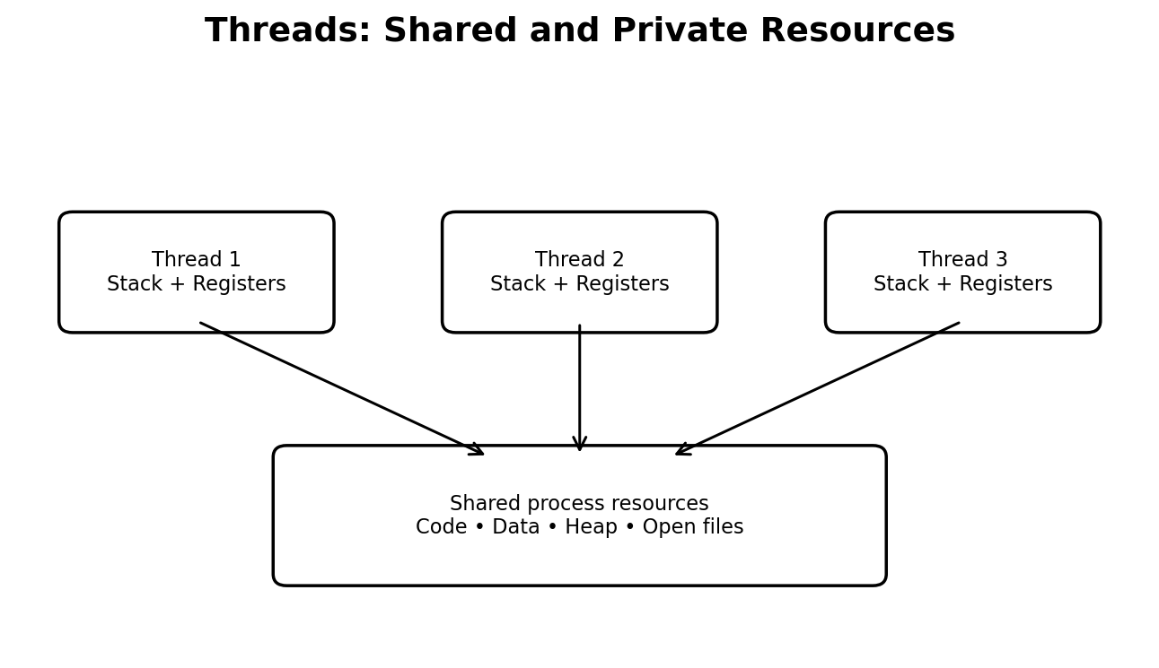

Q3 — User-Level and Kernel-Level Threads
User-level threads are managed by a runtime library without requiring the kernel to schedule each user thread individually. They can have low management overhead, but in a many-to-one model a blocking system call may block the entire process and multiple threads cannot execute in parallel on multiple cores.
Kernel-level threads are known to the operating system and are scheduled by the kernel. They support true parallel execution on multiple cores, but creation and switching may involve greater operating-system overhead.
Modern general-purpose operating systems commonly use kernel-scheduled threads for POSIX pthreads. The exact implementation is platform-dependent.

Q3 — Thread Mapping Models
Many-to-one maps many user threads to one kernel thread. It is simple but prevents true parallel execution and a blocking call can block all threads. One-to-one maps each user thread to a kernel thread, enabling parallelism but potentially creating many kernel threads.
Many-to-many maps many user threads onto a smaller or equal number of kernel threads. It can combine user-level flexibility with kernel-level parallelism, but its implementation and scheduling coordination are more complex.
For a Linux POSIX camera application, pthreads normally use a one-to-one mapping. A bounded pthread worker pool is therefore a practical design.

Q3 — One Thread per Camera vs Pool
One thread per camera gives each camera a dedicated execution path and can be easy to implement. With 64 cameras, however, 64 threads may create unnecessary scheduling and stack overhead if many cameras are idle or waiting for frames.
A pool of 4, 8 or 16 threads bounds concurrency. The best pool size depends on CPU cores, image-processing cost, I/O waits and memory bandwidth. CPU-bound work often benefits from a worker count near the available core count; I/O-bound work may benefit from more workers.
Use a thread-safe queue to deliver frames to workers. Include camera ID and timestamp with each frame so the output can be associated with its source and ordered when required.

Q3 — POSIX Thread Example
This program creates a small set of worker threads. Each thread processes a range of work. A real camera application would replace the loop with frame decoding and number-plate recognition.
#include <stdio.h>\n#include <pthread.h>\n#define N 4\nvoid *worker(void *arg) {\n long id = (long)arg;\n printf("Worker %ld processing frames\\n", id);\n return NULL;\n}\nint main(void) {\n pthread_t t[N];\n for (long i=0; i<N; i++)\n pthread_create(&t[i], NULL, worker, (void *)i);\n for (int i=0; i<N; i++) pthread_join(t[i], NULL);\n return 0;\n}

Q3 — Race Condition and Mutex
A race condition occurs when the result depends on the unpredictable order of concurrent operations. For example, a non-atomic counter++ usually consists of load, add and store. Two threads can interleave these operations and lose an increment.
A mutex provides mutual exclusion. A thread locks before updating the shared counter and unlocks afterwards. Other threads attempting to lock wait until the owner releases it.
Compile pthread programs with gcc -std=c11 -Wall -Wextra -pthread. Test the counter with and without a mutex over many iterations. The protected version should match the expected total.

Q3 — Speed-up and Scalability
Speed-up is calculated as S = T1 / Tp, where T1 is the single-thread execution time and Tp is the parallel execution time using p workers. Efficiency is E = S / p.
Speed-up may stop increasing because of serial work, lock contention, memory bandwidth, cache misses, thread scheduling overhead, I/O limits or fewer physical cores than workers. Amdahl’s Law estimates the maximum speed-up when a fraction of the program is serial.
Measure one-thread time and pool sizes 4, 8 and 16 on the same input data. Repeat several runs and report the average or median. Do not invent measured values; insert the actual timings from the student’s computer.

Q3 — Processes as an Alternative
Using processes instead of threads gives each camera worker a separate address space. This improves fault isolation: a crash in one worker need not corrupt the memory of other workers. However, processes require more memory and more expensive creation and switching in many cases.
Results must be combined through IPC such as pipes, message queues or shared memory. Threads can share result queues directly in the same address space, but require synchronisation.
Recommended design: use a bounded thread pool for normal frame processing. Use separate processes if image-processing libraries are unstable, security isolation is required, or workers need independent restart and resource limits.

Q3 — Evaluation and Conclusion
For 64 cameras, a fixed pool of 8 or 16 threads is a reasonable starting point, not a universal optimum. Benchmark 4, 8 and 16 workers with representative frame sizes and peak input rates. Monitor queue length, dropped frames, CPU use and end-to-end recognition latency.
Protect shared counters and result queues. Avoid holding a mutex while performing slow disk or network operations. Keep critical sections short and use condition variables to wake idle workers when new frames arrive.
Evidence expected: multithreaded source code, measured execution times, speed-up table, explanation of shared/private resources, thread-model comparison and test output.
Practical note: include actual terminal output and screenshots from your own execution.

Q4 — IPC: Introduction
Inter-Process Communication (IPC) allows separate processes to exchange data and coordinate activity. In a weather station, one process reads sensors while another validates, aggregates and analyses readings.
The main IPC models are message passing and shared memory. Message passing transfers messages through operating-system-managed mechanisms such as pipes and message queues. Shared memory maps the same memory region into multiple processes, allowing direct access to common data.
The correct choice depends on message size, throughput, reliability, ordering, process boundaries and synchronisation requirements.

Q4 — Pipe Communication
A pipe is a unidirectional byte stream. The process that writes data uses the write end, and the process that reads data uses the read end. After fork(), both processes inherit the descriptors, so each process should close the end it does not use.
The parent sensor process writes integer readings. The child analyser reads until read() returns zero, which indicates end-of-file. EOF occurs only after every open descriptor referring to the write end has been closed.
If the parent forgets to close fd[1], the child may wait forever because the kernel still sees an open writer. Closing unused descriptors is therefore essential for correct pipe behaviour.
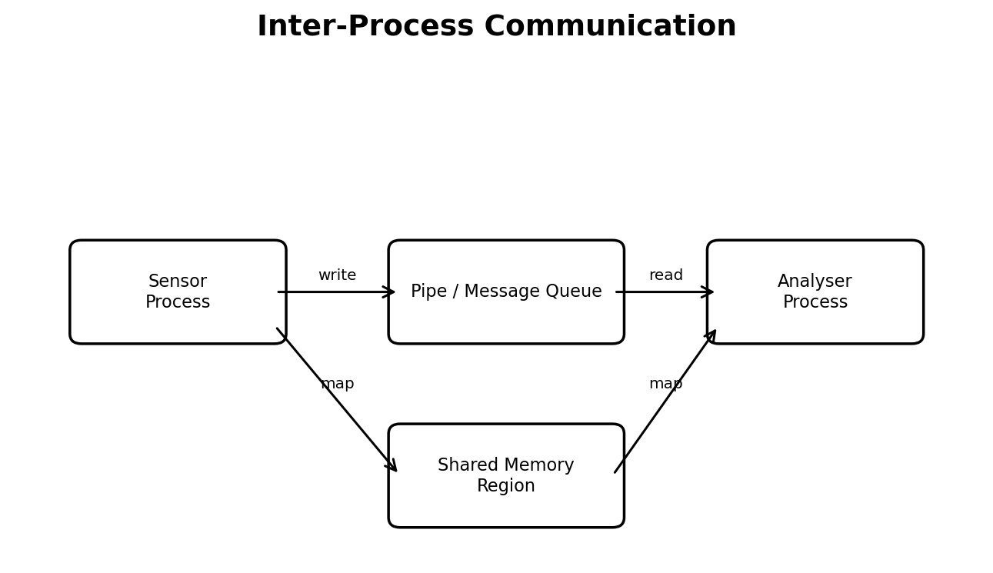

Q4 — Completed Pipe Program
The following child-side code completes TODO 1. It reads one integer at a time, updates count and sum, and tracks the maximum. The parent closes the write descriptor after sending all readings.
while (read(fd[0], &r, sizeof r) > 0) {\n if (count == 0 || r > max) max = r;\n sum += r;\n count++;\n}\nprintf("analyser: %d readings, average %.1f, max %d\\n",\n count, count ? (double)sum / count : 0.0, max);\nclose(fd[0]);\nfflush(stdout);\n_exit(0);

Q4 — Expected Pipe Output
For readings 31, 33, 36, 34, 41 and 38, the count is 6, the sum is 213, the average is 35.5 and the maximum is 41.
Expected output: analyser: 6 readings, average 35.5, max 41; reader: done. The analyser line normally appears before the reader’s final line because the parent waits for the child using waitpid().
A robust production program should handle partial reads and writes, EINTR and errors. The short assignment example assumes each small integer is transferred successfully in one write and read operation.

Q4 — Shared Memory
Shared memory allows two or more processes to map the same physical memory region into their virtual address spaces. After setup, one process can write data and another can read it without sending every byte through a pipe buffer.
Shared memory can be very fast for large data transfers because it avoids repeated copying through a kernel-managed message path. However, it does not automatically provide coordination. A producer may update a record while a consumer is reading it unless access is synchronised.
Use a process-shared semaphore, mutex or carefully designed atomic protocol to indicate when data is ready and when a buffer slot is free. Define ownership and shutdown behaviour clearly.

Q4 — Message Queue vs Shared Memory
A message queue stores discrete messages and preserves message boundaries. It can support priorities and convenient producer-consumer communication. The operating system manages queue operations and may copy message data between user and kernel space.
Shared memory exposes a common region and is efficient for large volumes. The application must manage indexes, buffer ownership, synchronisation and recovery if one process exits unexpectedly.
For small sensor readings, a pipe or message queue is simple and reliable. For large continuous blocks such as images or high-rate sensor batches, shared memory with semaphores may provide higher throughput.

Q4 — Transfer Measurement Plan
Measure transfer of 1 MB, 10 MB and 100 MB using the same machine, compiler, data format and number of repetitions. Use a monotonic clock such as clock_gettime(CLOCK_MONOTONIC) around the transfer operation.
Record elapsed time, throughput in MB/s, CPU usage and whether setup time is included. Repeat each test and report a median to reduce noise. Separate shared-memory setup cost from steady-state transfer cost.
Expected trend: shared memory may have lower per-byte overhead for large transfers, while pipes are easier to implement and may perform well for small streams. Actual performance depends on buffer size, kernel, cache and synchronisation design.

Q4 — Complexity and Design Decision
For n bytes, the basic data movement work is O(n) for both pipe and shared memory. The difference is the constant factor: a pipe commonly involves kernel-mediated copying, while shared memory can avoid repeated copying after mapping.
Shared memory has additional setup and synchronisation complexity. A pipe has simpler lifecycle and natural EOF behaviour. For the weather station’s small integer readings, a pipe is a suitable initial solution. If the pipeline grows to large batches or high-rate streams, benchmark shared memory.
Evidence expected: working pipe implementation, a second IPC implementation, transfer measurements for three sizes, and a justified choice.

Q5 — Synchronisation: Critical Section
A critical section is a code segment that accesses shared data and must not be executed concurrently by conflicting operations. In railway booking, the seat availability check and seat allocation must behave as one indivisible operation.
A correct solution to the critical-section problem must guarantee mutual exclusion, progress and bounded waiting. Mutual exclusion means at most one process is in the critical section. Progress means selection of the next entrant cannot be postponed indefinitely when the section is free. Bounded waiting limits how long a requester can be bypassed.
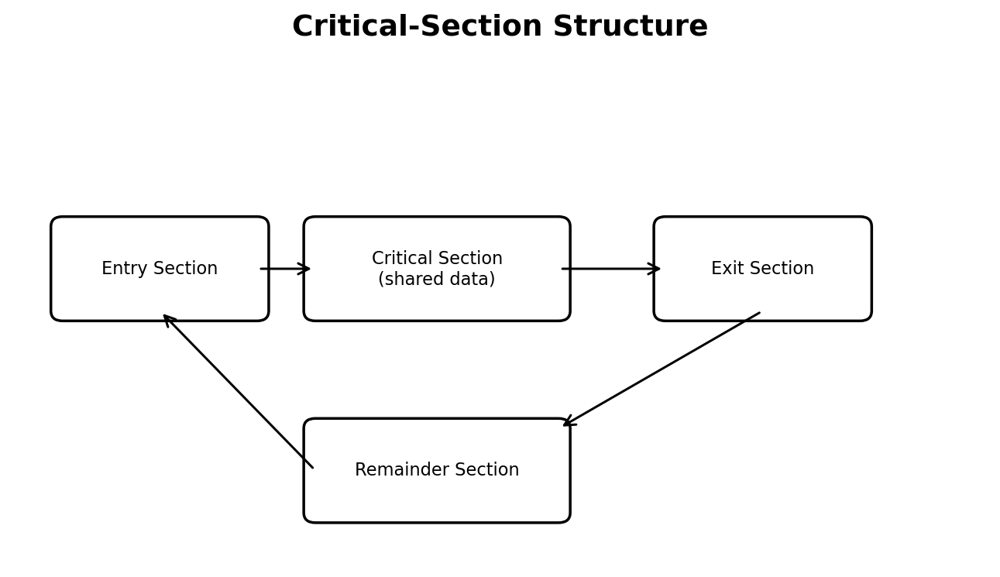

Q5 — Peterson’s Solution
Peterson’s algorithm is a software solution for two processes. It uses two intent flags and a turn variable. Each process announces interest, gives the other process priority when both compete, and waits while the other is interested and it is the other process’s turn.
Under the classical sequentially consistent memory model, Peterson’s algorithm satisfies mutual exclusion, progress and bounded waiting for two processes. It is mainly an educational demonstration rather than a production lock.
Modern processors and compilers may reorder memory operations. Without appropriate atomic operations and memory-order guarantees, the simple textbook code may not behave as expected. Use pthread mutexes or C11 atomics for real systems.

Q5 — Binary and Counting Semaphores
A semaphore is an integer synchronisation object accessed through atomic wait and signal operations. wait (also called P or down) decrements the semaphore when possible or blocks the caller. signal (V or up) increments it and may wake a waiting thread.
A binary semaphore is commonly used for a 0/1 state or mutual-exclusion-like coordination. A counting semaphore represents multiple identical resources. For example, a train with 100 available seats can use a counting semaphore to represent capacity, although a real booking system must also track seat identity.
A mutex is usually preferable for protecting a critical section because it has ownership semantics. Semaphores are especially useful for signalling and resource counting.

